**5.12. Class tasks and assignments**

这部分内容是给今天上课了的同学完成。如果你今天没有来上课，请看下两页的安排。

Group in-class writing (小组课堂讨论活动，每个小组提交一份就好，今天中午12点前完成交给课代表，然后课代表统一交给叶老师。请利用好课堂时间有效率地和组员一起完成。)

|  |
| --- |
| Your group number _______ (你们小组的号码) |
| Who participated in today’s discussion: （今天参与了讨论的同学名字和他们的字母代号ABCD…） |
| Who is submitting this group form today: Member D  今天负责提交作业的小组代表___________ |
| |  | | --- | | **Final group project**  **Step 3: Problem solving (Member D)** | | * Give 3 suggestions to solve this problem/issue. * Summarize 3 sources of information (Finish the table #2)   Table #2 Comparing the efforts to improve the situation in each region   |  |  | | --- | --- | | What is the issue? ___________  Which country/region is under comparison?_________ | | | What has China done to improve the situation?  Who benefits from these efforts? |  | | What has _______ done to improve the situation?  Who benefits from these efforts? |  | | What do China and _____ have in common in their efforts? Explain. |  | | How are China and _____ different in their efforts? Give examples and explain why. | Due to its slow start, China used money to buy technology in the past, and the only core technology fields were scattered. However, China has increased investment in the field of convenience technology in recent years and achieved rapid development. For example, Alipay , Meituan, and so on.  Due to the early start of science and technology in the USA, various core technologies are perfect and closely integrated, and the USA also pays attention to the development of students' innovative thinking. For example, the number of Nobel Prize winners in the United States is far greater than that in China. | | What is surprising you in this comparison? | China's core technology development areas have shortcomings, but this is also in line with China's national conditions. As a developing country, China still has a considerable way to struggle for. | | How has culture related to these efforts to improve this situation? |  | | What other subject (disciplinary) knowledge will help to improve this situation? |  | | Summarize the 3 sources of information you reviewed. Find 3 articles that help you find solutions to your program. Write 1 paragraph to summarize each article. (Pay attention to the strategies of writing summaries) | | | Summary of the 1st article. Write here | | | Summary of the 2nd article. Write here | | | Summary of the 3rd article. Write here | | | |

**Assignment for next class:**

* Announcement: future classes will be asynchronous.
* Read Chapter 20 before the next class.
* Finish your weekly reflective report. (At least 250 words). Due Sunday night 11:59 pm.
  + Think about the issue for your final project:
  + What other subjects are connected with this issue?
  + What can citizens do to help improve the situation?
  + What can YOU do to improve the situation?
  + Is intercultural competence important in helping to improve this situation?
  + How is learning English related to your major and your goals?
  + Is learning about other cultures helpful in your major and goals? Please explain.
  + At least 250 words.
  + Read the rubric closely and include the rubric in your paper

|  |  |  |
| --- | --- | --- |
| **Rubric: Weekly Journal Report (updated on April 5th, 2022)** | | |
| **Point** | **Rationale** | **Suggestions** |
| 5 | * Respond to **all** of the questions and prompts with **great details** * Little to no grammar/spelling mistakes * Author’s genuine work * Follow all of the format instructions correctly (write down the author’s name, include this rubric, at least 250 words, list the word count, paragraphs and topic sentences) | No suggestions. Continue with your good work. |
| 4 | * Respond to **some or all** of the questions and prompts with **some details** *or* * **Some** grammar/spelling mistakes *or* * Follow all of the format instructions correctly (write down the author’s name, include this rubric, at least 250 words, list the word count, paragraphs and topic sentences) | Read your essay again and consider how to add more details, correct grammar mistakes. |
| 3 | * Respond to **some or all** of the questions and prompts with **some details** *or* * **Some** grammar/spelling mistakes *or* * Did not meet some format requirements, missing the author’s name, or this rubric, or the word count or paragraphs and topic sentences | Read your essay again and consider how to add more details, correct grammar mistakes. Remember to follow the instructions. |
| 2 | * Respond to **some** of the questions and prompts with **little details** *or* * **Many** grammar/spelling mistakes (incomprehensible) * Not the author’s genuine work (work is mostly plagiarized or translated online) * Did not meet some format requirements, missing the author’s name, or this rubric, or the word count or paragraphs and topic sentences | Rewrite your essay.  Do not plagiarize work again. |
| 1-0 | * The author did minimal work, *or* * The work was totally plagiarized or the work was from online translation (the work does not reflect the author’s proficiency or voice) * Did not follow the format requirements. | Rewrite your essay. |

Important note: 因为时间冲突没有上课的同学，请完成以下内容。

**因为这个是期末考试项目，所以你们也是按照小组完成。如果你不了解如何完成小组作业，可以问课代表。**

**期末项目小组分组**

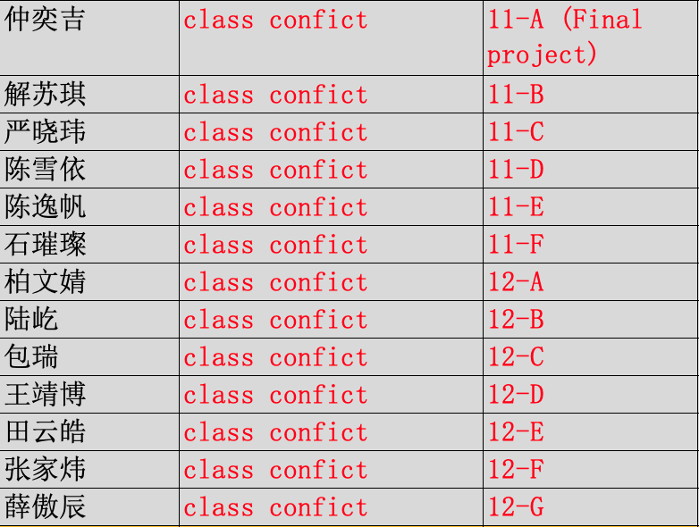

You need to submit the form to the Course Representative by **Sunday night 11:59pm**. (Don’t forget, you also need to finish weekly reflective report, that is also due Sunday night. That means, you need to submit **multiple things** to the Course Representative by Sunday night.)

|  |
| --- |
| Your group number _______ (你们小组的号码) |
| Who participated in today’s discussion: （今天参与了讨论的同学名字和他们的字母代号ABCD…） |
| Who is submitting this group form today: Member D  今天负责提交作业的小组代表名字___________  **Watch today’s recorded class, and answer the following questions:**   1. Did your team members watch the recorded class? 2. In this week’s lecture, I introduced five strategies of writing a summary. What are they? |
| |  | | --- | | **Final group project**  **Step 2: Find an issue under this topic (Member D)** | | * Give 3 suggestions to solve this problem/issue. * Summarize 3 sources of information (Finish the table #2)   Table #2 Comparing the efforts to improve the situation in each region   |  |  | | --- | --- | | What is the issue? ___________  Which country/region is under comparison?_________ | | | What has China done to improve the situation?  Who benefits from these efforts? |  | | What has _______ done to improve the situation?  Who benefits from these efforts? |  | | What do China and _____ have in common in their efforts? Explain. |  | | How are China and _____ different in their efforts? Give examples and explain why. |  | | What is surprising you in this comparison? |  | | How has culture related to these efforts to improve this situation? |  | | What other subject (disciplinary) knowledge will help to improve this situation? |  | | Summarize the 3 sources of information you reviewed. Find 3 articles that help you find solutions to your program. Write 1 paragraph to summarize each article. (Pay attention to the strategies of writing summaries) | | | Summary of the 1st article. Write here | | | Summary of the 2nd article. Write here | | | Summary of the 3rd article. Write here | | | |

**Assignment for next class:**

* Announcement: future classes will be asynchronous.
* Read Chapter 20 before the next class.
* Finish your weekly reflective report. (At least 250 words). Due Sunday night 11:59 pm.
  + Think about the issue for your final project:
  + What other subjects are connected with this issue?
  + What can citizens do to help improve the situation?
  + What can YOU do to improve the situation?
  + Is intercultural competence important in helping to improve this situation?
  + How is learning English related to your major and your goals?
  + Is learning about other cultures helpful in your major and goals? Please explain.
  + At least 250 words.
  + Read the rubric closely and include the rubric in your paper

|  |  |  |
| --- | --- | --- |
| **Rubric: Weekly Journal Report (updated on April 5th, 2022)** | | |
| **Point** | **Rationale** | **Suggestions** |
| 5 | * Respond to **all** of the questions and prompts with **great details** * Little to no grammar/spelling mistakes * Author’s genuine work * Follow all of the format instructions correctly (write down the author’s name, include this rubric, at least 250 words, list the word count, paragraphs and topic sentences) | No suggestions. Continue with your good work. |
| 4 | * Respond to **some or all** of the questions and prompts with **some details** *or* * **Some** grammar/spelling mistakes *or* * Follow all of the format instructions correctly (write down the author’s name, include this rubric, at least 250 words, list the word count, paragraphs and topic sentences) | Read your essay again and consider how to add more details, correct grammar mistakes. |
| 3 | * Respond to **some or all** of the questions and prompts with **some details** *or* * **Some** grammar/spelling mistakes *or* * Did not meet some format requirements, missing the author’s name, or this rubric, or the word count or paragraphs and topic sentences | Read your essay again and consider how to add more details, correct grammar mistakes. Remember to follow the instructions. |
| 2 | * Respond to **some** of the questions and prompts with **little details** *or* * **Many** grammar/spelling mistakes (incomprehensible) * Not the author’s genuine work (work is mostly plagiarized or translated online) * Did not meet some format requirements, missing the author’s name, or this rubric, or the word count or paragraphs and topic sentences | Rewrite your essay.  Do not plagiarize work again. |
| 1-0 | * The author did minimal work, *or* * The work was totally plagiarized or the work was from online translation (the work does not reflect the author’s proficiency or voice) * Did not follow the format requirements. | Rewrite your essay. |